Performance & Performance Studies MFA
Performance and Performance Studies (P+PS) at Pratt Institute is a small and intensive graduate degree program for students seeking to maximize and individualize their graduate experience and draw on the rich performance and cultural worlds of Brooklyn and greater New York City. Pratt has long been internationally known for studio programs with strong liberal arts components; the Performance and Performance Studies (P+PS) program is designed to enable students to take full advantage of an increasingly vibrant intersection of performance practices and theory.

Thank you
Extracurricular was realized only through the talent of the fantastic artist scholars featured this evening. A sincere thank you to each of you for sharing a bit of your heart! Much appreciation, as well, to our audience. Thank you for your patronage and support.

Our gratitude is also extended to the Performance & Performance Studies Program for their sponsorship and most especially to Ashley Alvarez; an invaluable asset to us all.

Warmly,
Renae, Feng, & Mary

Performance & Performance Studies, MFA
200 Willoughby Avenue, DeKalb Hall 304
Brooklyn, New York 11205 | 718.399.4512

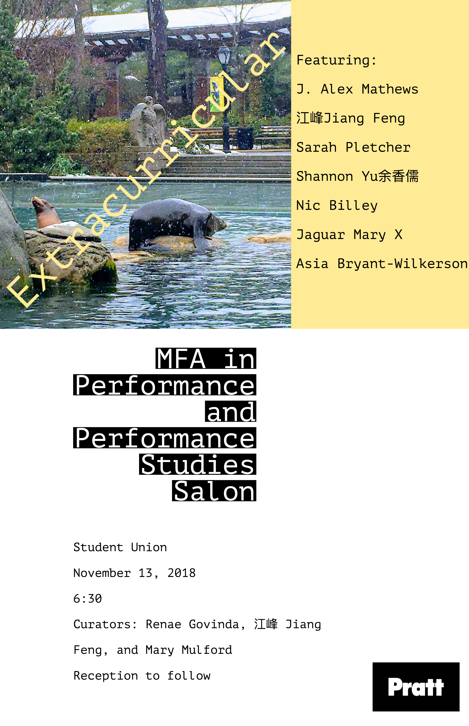
Welcome  1  Asia Bryant-Wilkerson | After, My Mother  江峰 Jiang Feng | Yell-Low 黃黃／惶惶  2  J. Alex Mathews | striking/light  Sarah Pletcher | Letters to my babies  3  Jaguar Mary X | Un  Shannon Yu 余香儒 & Nic Billey | Back Pack |  |  | Please join us for a reception  celebrating our artists.

Asia Bryant-Wilkerson
Asia Bryant-WIlkerson is a poet & teaching artist born and raised in South Central, LA. She has a degree in communication studies from the University of San Francisco. She was on the 2017 Root Slam National team which was comprised of all queer women of color and she is Berkeley Slam's 2017 & 18 individual and women’s champ.
Asia is a sharing a collection of poems regarding death, time and blackness called After, My Mother.

江峰 Jiang Feng
江峰 Jiang Feng [Last name, First name] is a gender non-conforming and multi-disciplinary performance artist working across-genres in movement and theatre as a dancer, actor and singer. They are also a writer, radio show host, freelance model, filmmaker and Performance Studies scholar. He attained her B.A. in English and Chinese literature from National Taiwan University in 2016, and received a 2015 R.O.C. Government Fellowship to study and research dance abroad. Recently, she received “Grants for 20-40-Year-Old Writers” from Ministry of Culture in Taiwan.
Yell-Low 黃黃／惶惶 is a provocative manifesto of the low visibility and socio-political status of Asians and Asian-USians in the “West.” Performers: Renae Govinda, Horizon Miguel, Anderson Wang, Brandon Weber

1

J. Alex Mathews  J. Alex Mathews is an arts practitioner with a background in performance, arts administration/consulting, production, and teaching. After nearly eleven years working and creating in Los Angeles, she is now based in Brooklyn.  striking/light flirts with fantasy and examines desire. It is a solo work in development investigating the power of intimacy and sexuality, made and unmade. An ongoing quest to embody a desirous and illuminated self, as well as share it.  Sarah Pletcher  Sarah Pletcher works mainly in performance and fibers to discuss what it means to inhabit a "female" body from the very physical experience to a very conceptual understanding of the unspoken implications. More specifically she makes work surrounding pregnancy and maternity. She tries to deconstruct the traditional lies and mythologies surrounding motherhood and reconstruct then through a queer narrative. Through this she tries to understand what maternity and family might look like in non-heteronormative, queer families. Her performances vary from existing only in the experience of the live viewer to being specifically performed for the camera (video and photography.)  Letters to my babies was sparked by a process Sarah developed a few years back, where she makes felt (matted wool) in her vaginal track. The whole process mimics the process of pregnancy in the technicalities of it to the emotional labor. During a period of time in 2017 she was making three to five felt babies a week. This marked the beginning of letter writing to the babies during their gestation period. Sarah will be reading a selection of these letters. |  |  | Jaguar Mary X  Jaguar Mary X is a performance artist, glossolalia vocalist, filmmaker and hoop dancer. She began her practice as a filmmaker in New York in the early 90’s as Jocelyn Taylor, a member of DIVA-TV, an affinity group of ACT-UP, the AIDS Coalition to Unleash Power. Jaguar Mary aka Jocelyn Taylor has shown internationally, at the Johannesburg and Havana Biennials, and in galleries in Venezuela, Canada, France, the Netherlands and Dietch Projects in New York. She’s also collaborated with feminist artists Annie Sprinkle, Alice O’Malley, Yvonne Rainer and Cheryl Dunye and others. She has an MFA in Film and Video from California Institute of the Arts and is currently a member of the inaugural Performance and Performance Studies, MFA cohort at Pratt Institute in New York.  Un (A Mythical Bird performance) is a twirling dance by an avatar created by Jaguar Mary X called Mythic Bird. In Un, Mythic Bird performs the task of the Un-Doer. In the action of continuous spiraling, Mythic Bird creates a centrifugal release of compression for the witnessing audience. The audience is asked to breathe deeply to their own rhythms during the performance. While there are many traditions of whirling ritual dance, Jaguar Mary's performance draws from the Sufi dervish and Indigenous hoop dance traditions. [Music: Chacarera Drums by Alessandro D'Aloia]  Shannon Yu 余香儒 & Nic Billey  Shannon Yu余香儒is a second year in Master of Fine Arts: Performance and Performance Studies, Pratt Institute.  Nic Billey is a third year in Master of Fine Arts: Performance and Performance Studies, Pratt Institute.  Back Pack …What are we carrying with us? Do we choose to carry them or were they put upon us? Are they useful at all?
2 |  |  | 3

